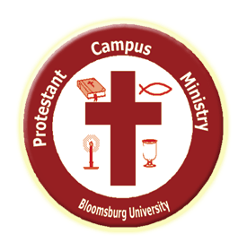
Protestant Campus Ministry Weekly Update
All are welcome to join us as we explore our faith, grow, learn, worship, and serve together!

Final Exam Snack Basket
First Presbyterian has kindly sent PCM a basket of yummy snacks as well as pencils and “post its.” Come by the office today or next week during my office hours to grab some study goodies or to hang out and study here! Christ’s peace and strength be with you as you complete your semester’s work!
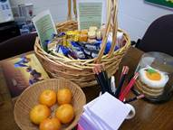

PCM Hoodies
Now available for order - a navy blue hoodie with PCM’s logo and our theme verse for the school year (Isaiah 43:19). Order due by the end of next week, Dec 12 and we will have them early next semester. Approximate cost is $25 dollars (due after winter break). Come by the office or email Pastor Jill by Friday Dec 12 with your size (small, medium, large or extra large - standard unisex sizes).

Advent Resources
May you find moments of quiet reflection and connection with Christ during the weeks leading up to Christmas. Below are some recommended resources that may help you prepare spiritually for Christmas amidst the busyness and fun of the season.

What is Advent? See this “Advent in 2 Minutes” video: https://www.youtube.com/watch?v=S02KOlw7dlA
Advent devotionals and other resources:
http://www.amazon.com/Watch-Light-Readings-Adv…/…/087486917X
http://www.androidpit.com/…/com.simexusa.adventdevotions2014
http://d365.org/
http://www.crivoice.org/advent1.html
http://pray-as-you-go.org/prayer-resources/advent-retreat/
http://godspace-msa.com/2013/…/13/advent-resources-for-2013/

MORE INFO…

Join our Facebook group for another way to connect and keep updated: https://www.facebook.com/groups/2202395536

Visit our website for information on other upcoming events and opportunities: http://bupcm.weebly.com

Contact one of our student leaders:
Kasey Jones, Co-President, Worship Leader, krj51994@huskies.bloomu.edu
Zachary Gilbert, Co-President, PR/Website, zdg46897@huskies.bloomu.edu
Hasby Firdauz, Treasurer, Outreach Coordinator, hkf67021@huskies.bloomu.edu
Darion Nomie, Secretary, Service Coordinator, dcn11871@huskies.bloomu.edu

Come visit Pastor Jill:
My office hours this semester in KUB 420 are…
T, TH, F – 9:30 AM – 2:30 PM
M – 10:00 AM – 12:30 PM
You can call or email to make an appointment or just come by to chat or for prayer. I’d love to meet with you!

Rev. Jill Young
Protestant Campus Minister
Bloomsburg University
420 Kehr Union Building, Box 28
570-389-4950
jyoung@bloomu.edu
http://bupcm.weebly.com
Find us on Facebook: Bloomsburg University Protestant Campus Ministry

